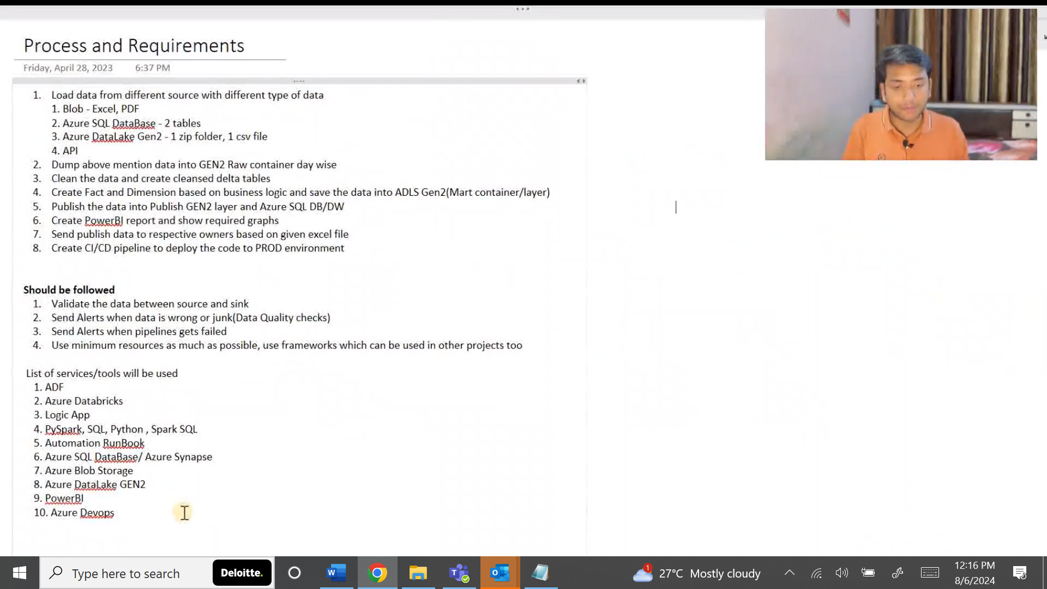 vtrf c

CSV files from source via ADF will be stored in ADLS Gen2 . This will be stored in ADLS Gen2 in zip format/zip folders . First, we have to extract those files and then we have to load it.

API will be hosted on cloud. So, we will fetch those records from the API.

Data from publish layer i.e; final layer data will be stored in 2 different places, ADLS Gen2 and Azure SQL/Azure DWH i.e; Azure Synapse. Because data lake is something not accessible by end users because they do not know how to write that query which means how to import the data. Azure SQL is something like everyone knows about it like writing simple statement.

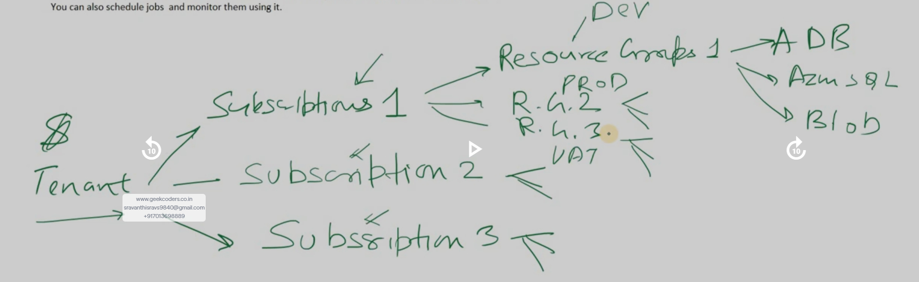

Here Tenant can be organization. If organization is geek coders, we can have multiple subscriptions here. Subscription1 is for Team1. Subscription2 is for team 2. Subscription3 is for team3. Inside Subscription1 , we can have 1 resource group for DEV environment. 2nd resource group is for PROD environment. 3rd resource group is for UAT environment.

In ADF: Suppose we are creating one resource in the region East US, then 2nd resource also should be in same region otherwise we may have more cost for all these resources or time will take a lot.

